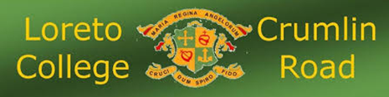

Agreed Report of Board of Management Meeting Wednesday April 24th, 2024

- The BOM extended its thanks to the staff for their engagement with professional development.
- A list of school trips and events were shared with the BOM. The BOM commended staff for the opportunities and experiences being provided for the pupils.
- The BOM congratulated the staff involved on two very successful information nights for TY and LCA (April 4th) and incoming 1st years (April 17th).
- The BOM noted the work being done by Nicole Walsh, on rolling out the new book scheme.
- The BOM noted that The Loreto Trust have advertised the position of CEO of the Loreto Education Centre.
- The BOM would like to acknowledge all the effort made by the BOM, on securing a new PA system for September.
- The BOM were delighted to have members of the Student Council visit the meeting (Victory John & Stephanie Omozusi) to discuss the work they have carried out this year and their plans going forward.

